**DATA SCIENCE**

**(Project)**



**PROJECT TITLE**

FINAL PROJECT S2022(PAKISTAN NEW AND OLD CAR)

**SUBMITTED TO:**

MAZHAR JAVED AWAN

**Submitted By:**

SYED ALI MEHDI

F2019065022

**Scope of the project:**

In this project studied the data which was about the used cars and having features and in starting I visualized few of the things which were interesting to know the data or key points to the data and then have applied some regression models to predict the used cars prices and the error and accuracy score has been credited in the code part.

**Code Explanantion:**

Using some basic libraries used for mostly every data science project and then reading the data from csv file.

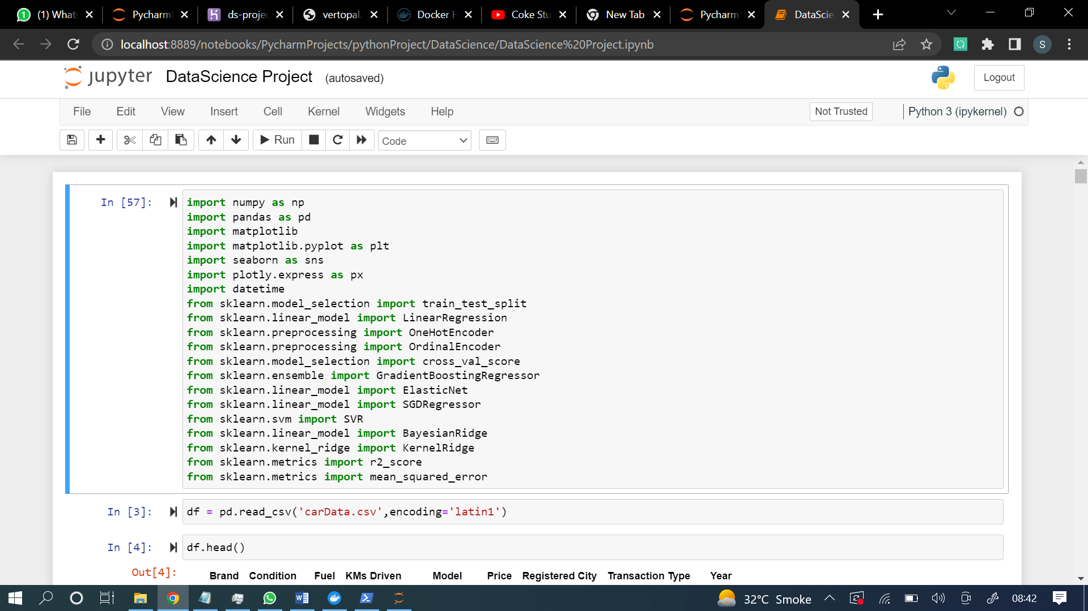

Exploring the information about the data we have

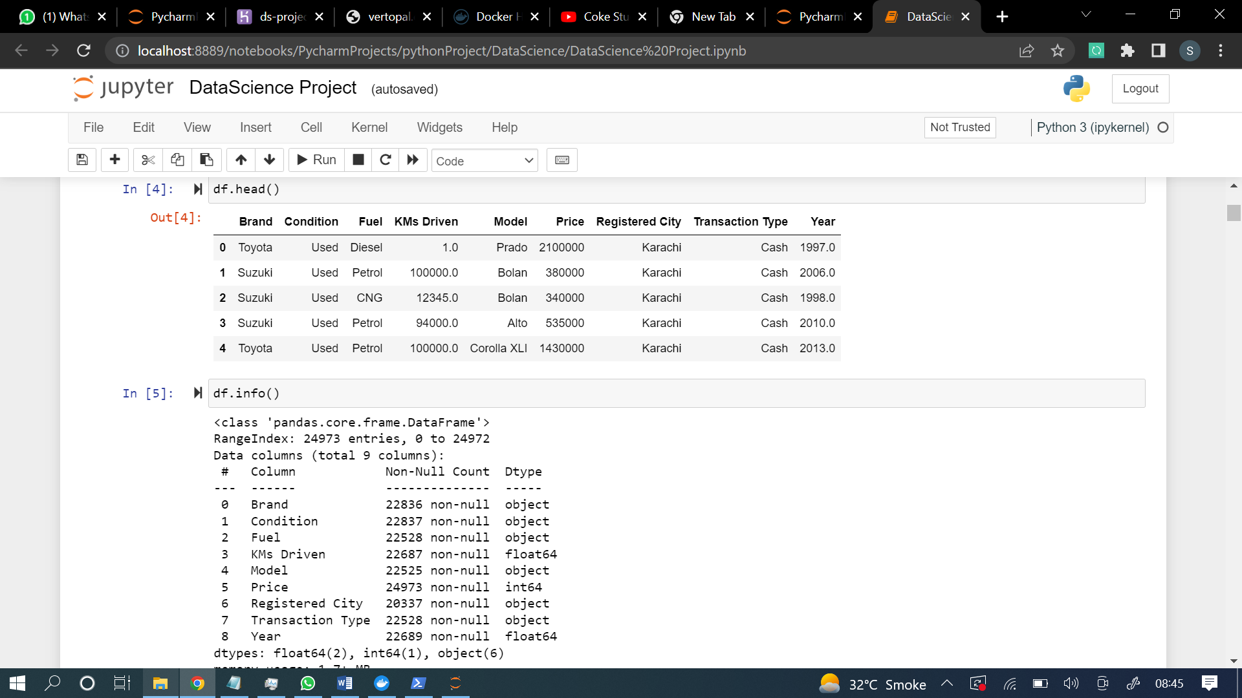

There were missing values also present in the data set and I handled them using some python functions is null command telling the count of missing values present in every columns and then filling them using fillna on the basis of mode of that particular column.

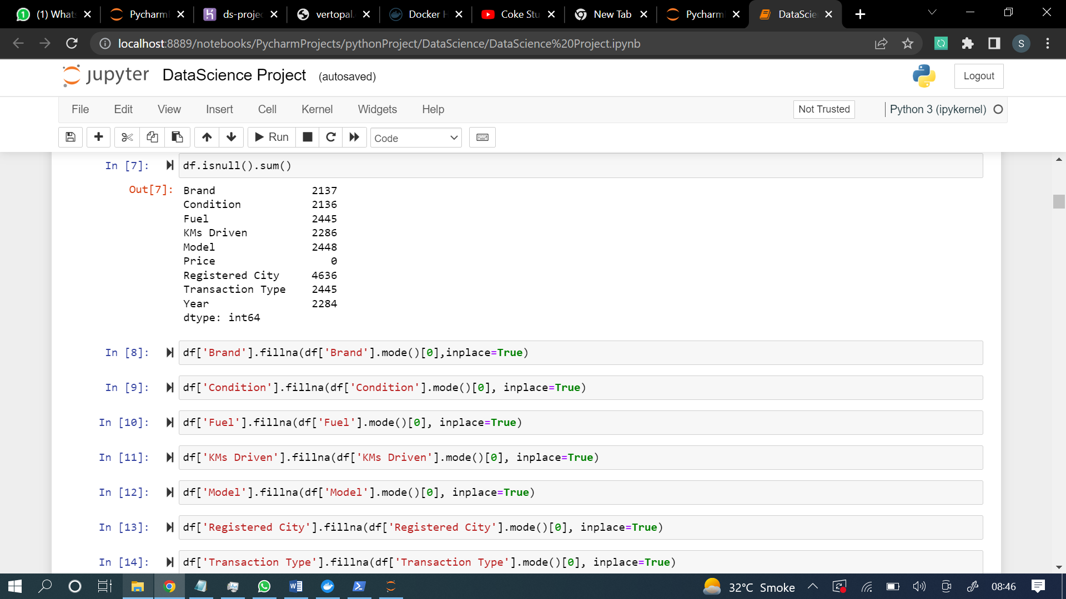

After filling the missing values again checked the count of missing values in the data and then I got zero missing values.

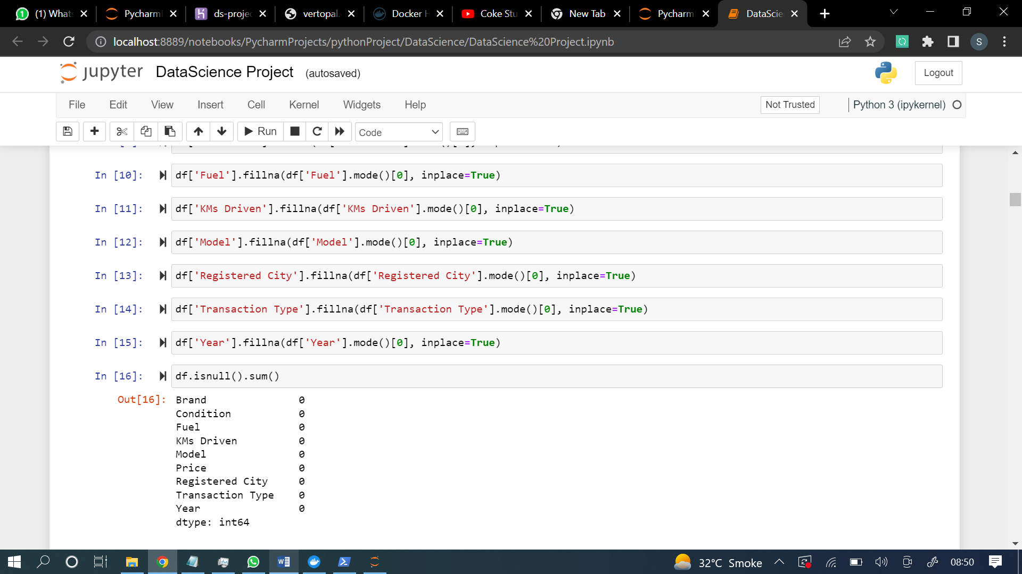

Taking the log of the values because they are very big and creating disruption in the data which causes to lose the accuracy or giving bad visualizations.

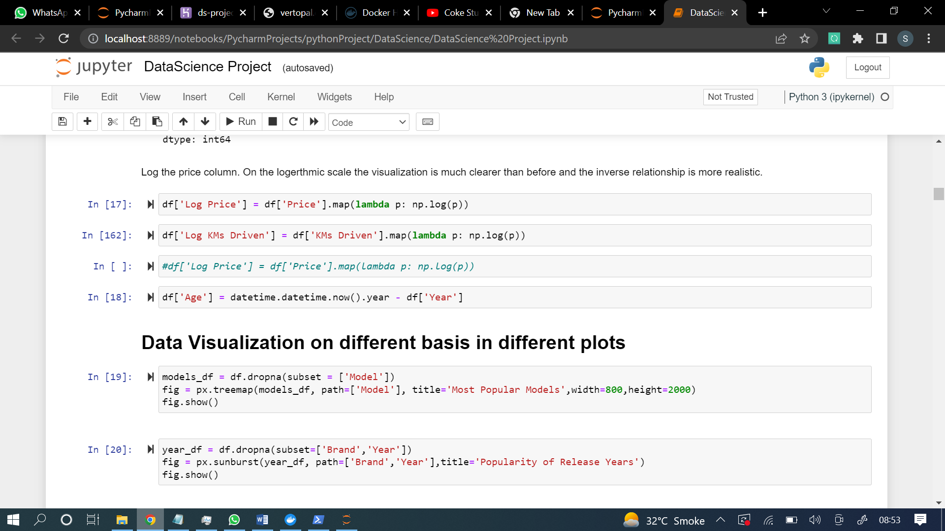

And now visualization part starts and here we go with the visualization code and graphs.

Bellow are 5 sns graphs

1st SNS graph (correlation btw release year and kms driven)

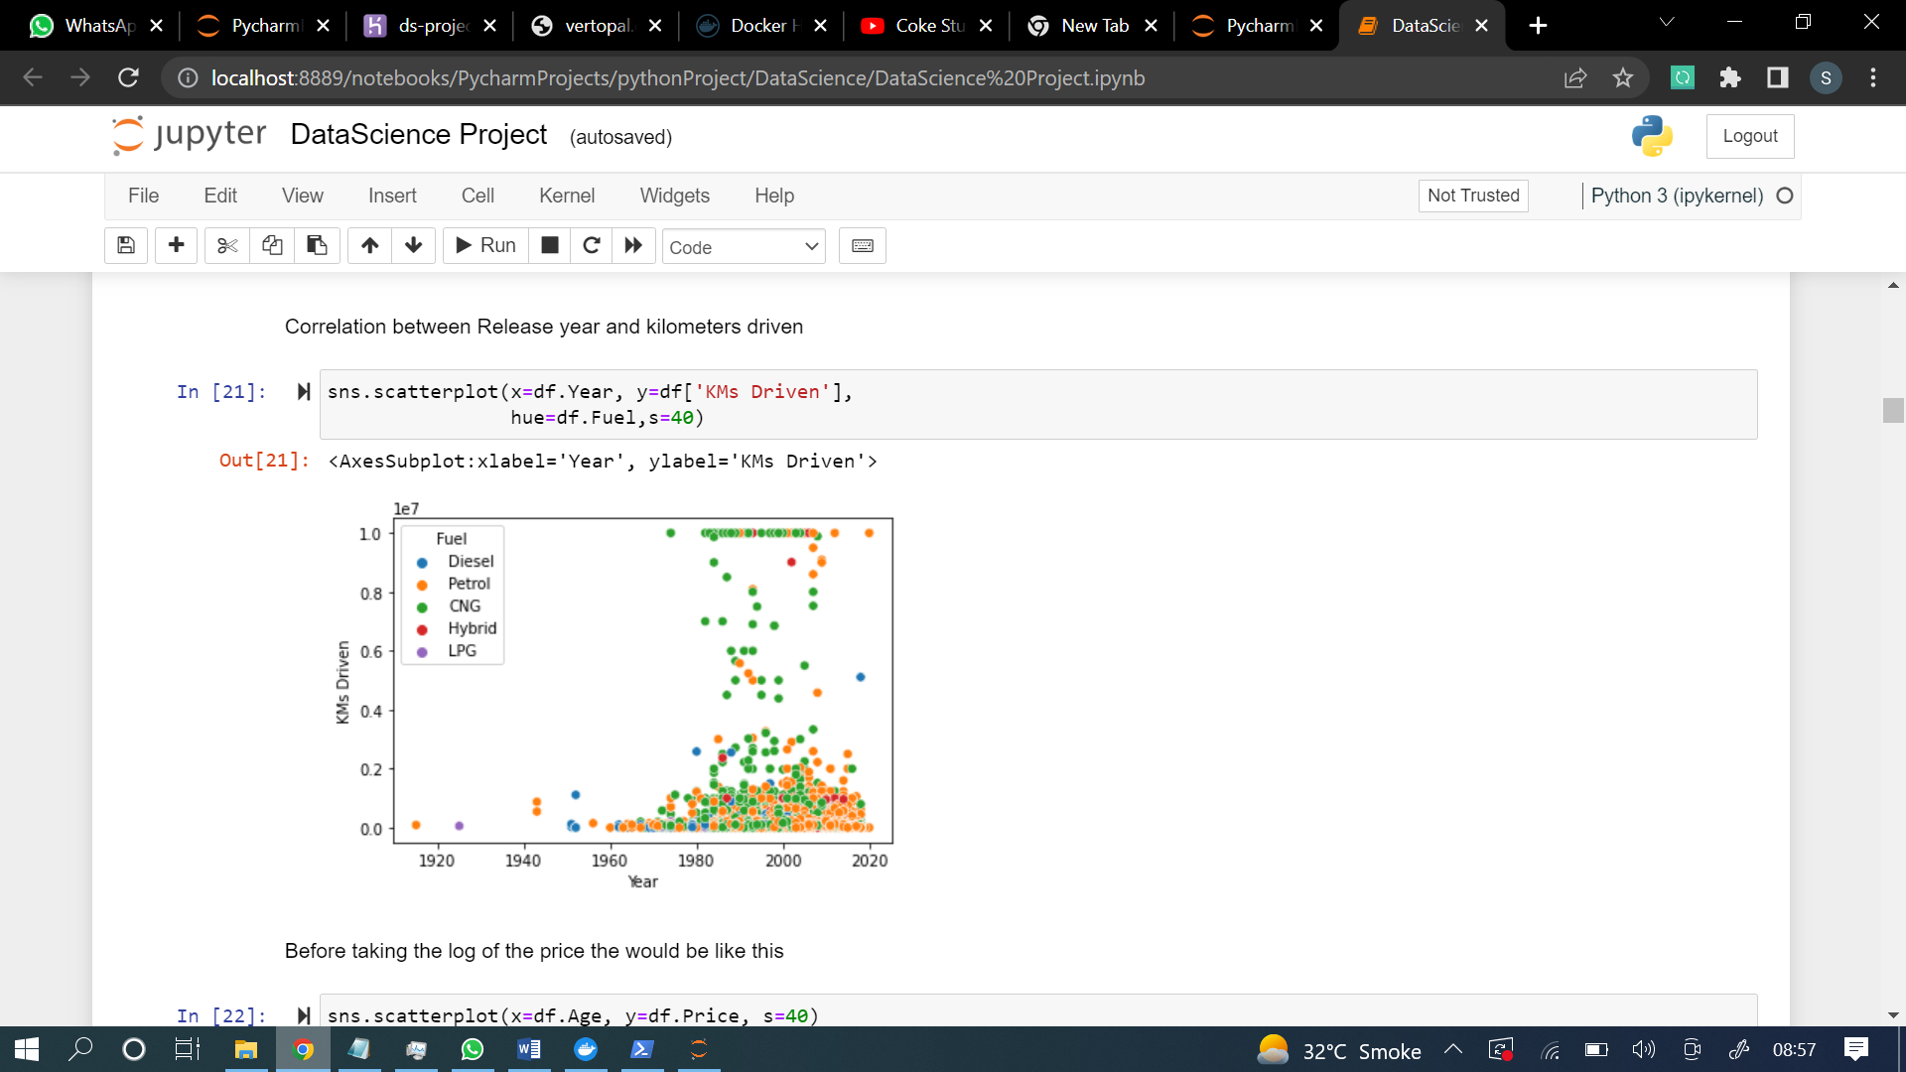

2nd SNS graph(before logging the price distribution graph is like this)

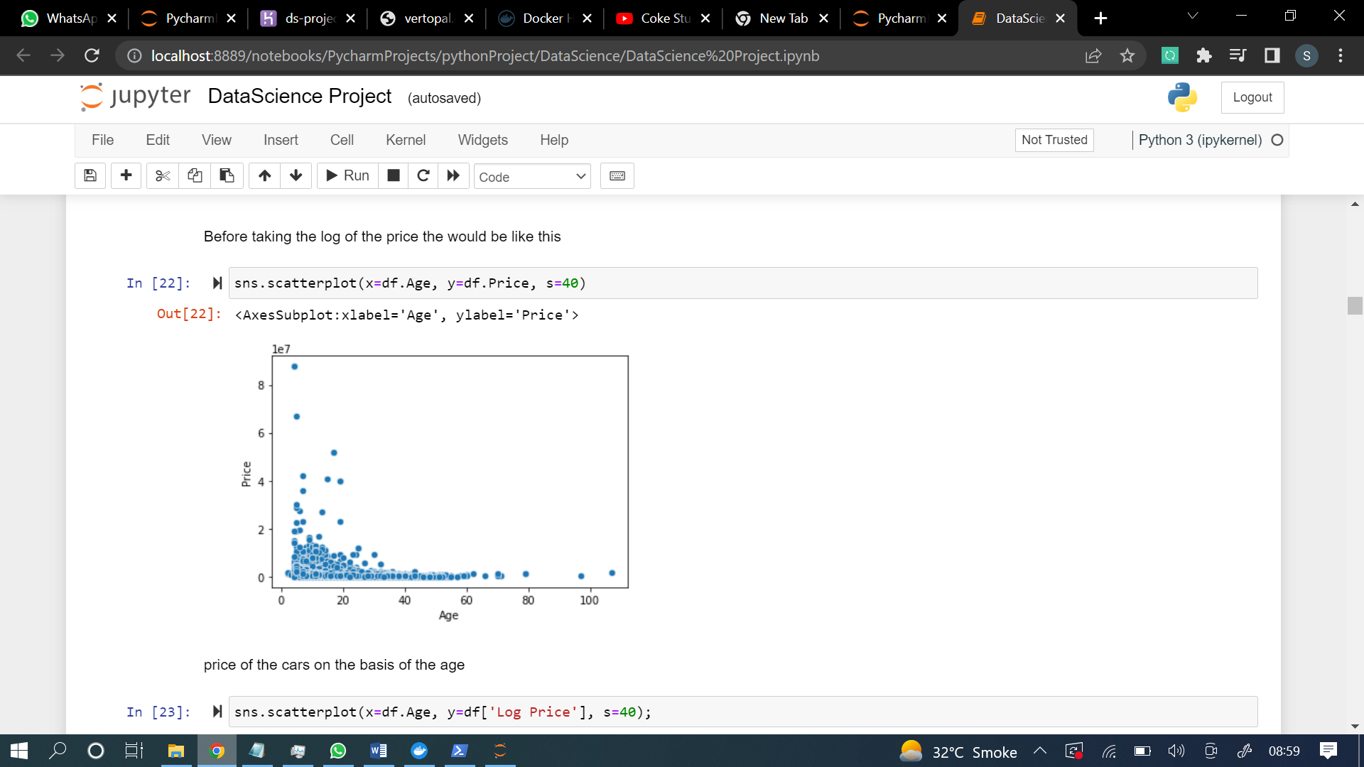

3rd SNS graph(after logging the price distribution graph is like this)

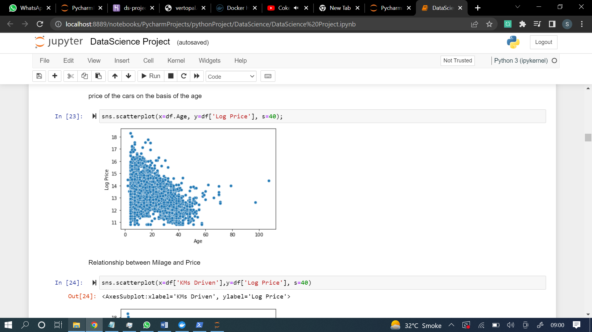

4th SNS graph(relation between millage and price)

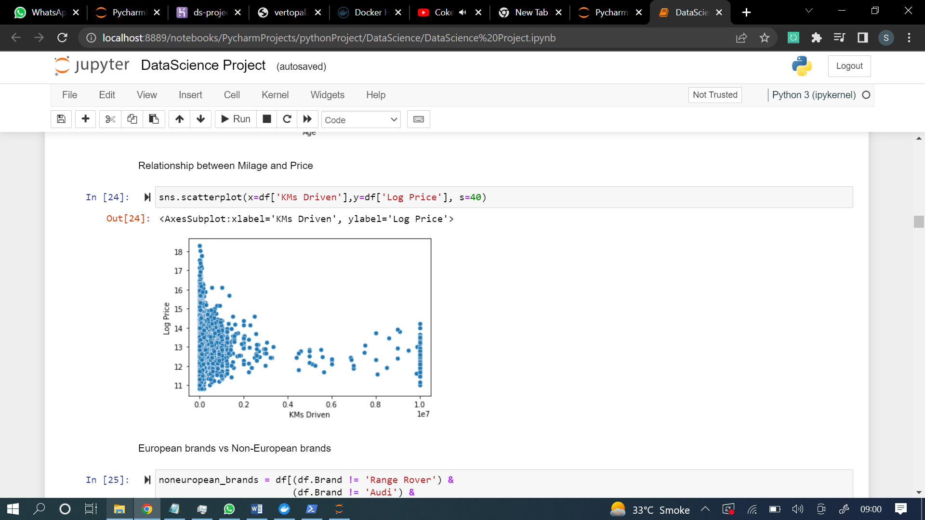

5th SNS graph (europen brand vs non-european brand)

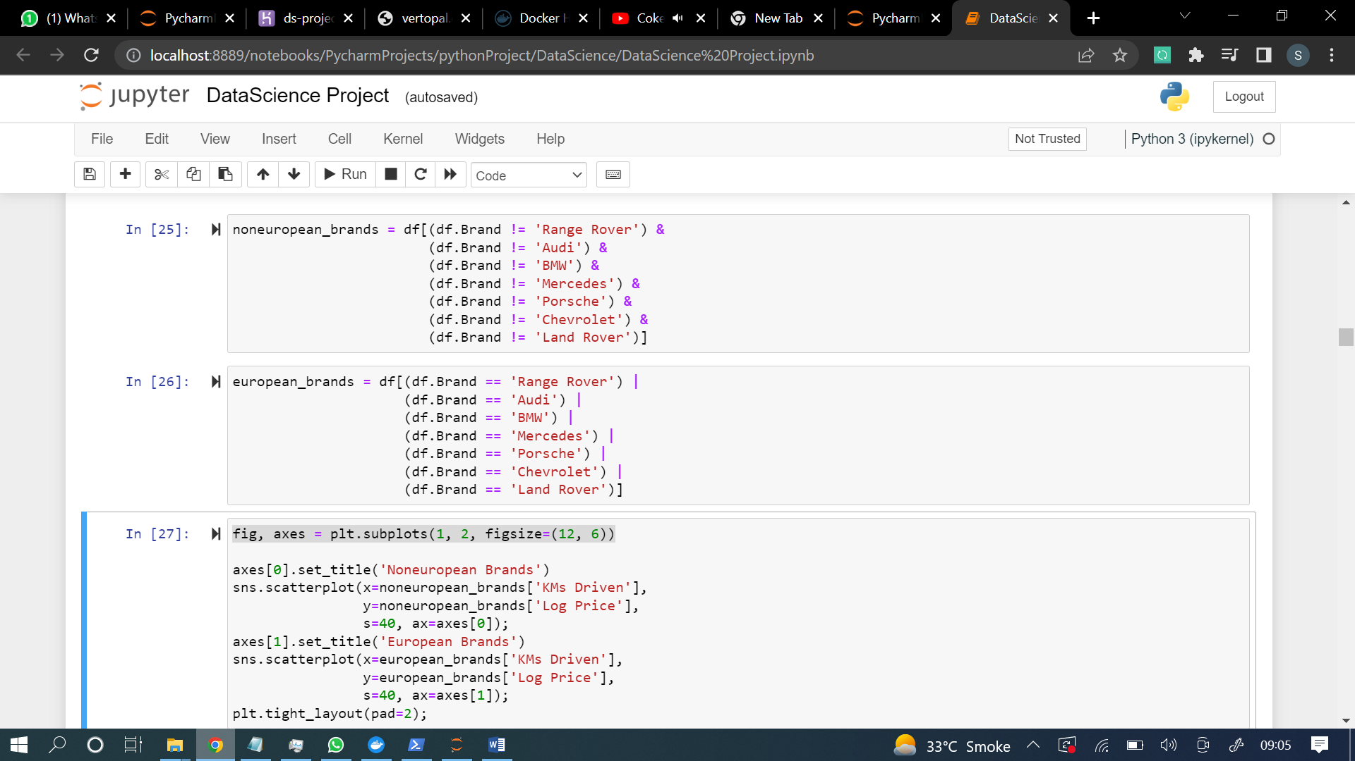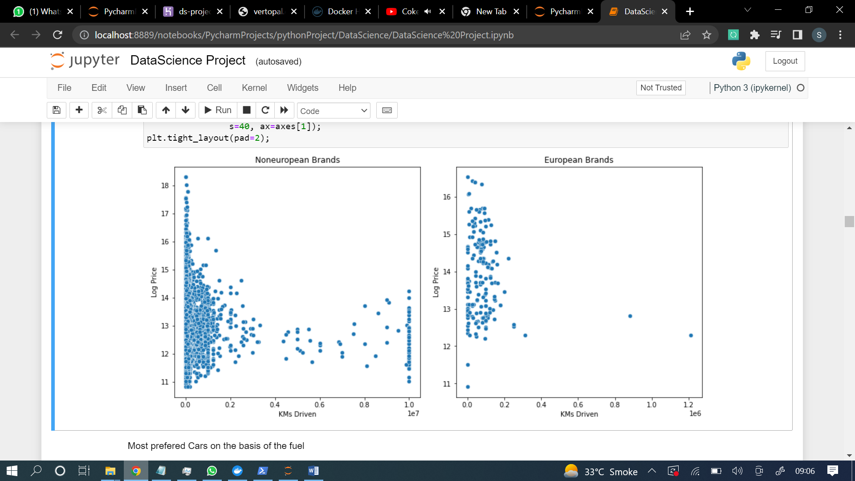

5 plots of matplotlib

1st plot(Most prefered Cars on the basis of the fuel)

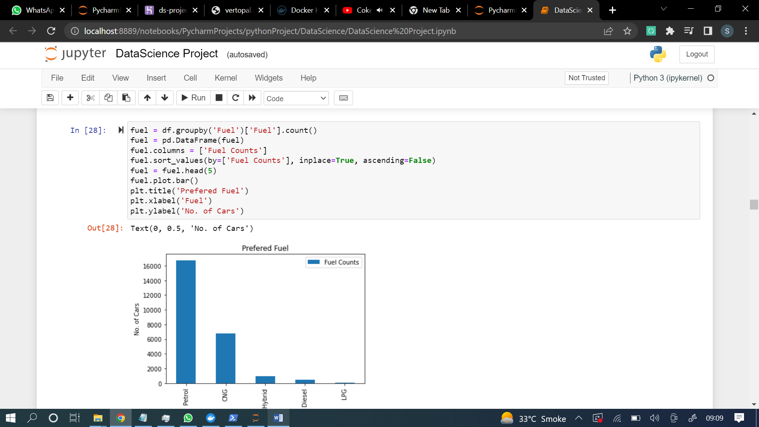

2nd plot(Sales of top 10 brands)

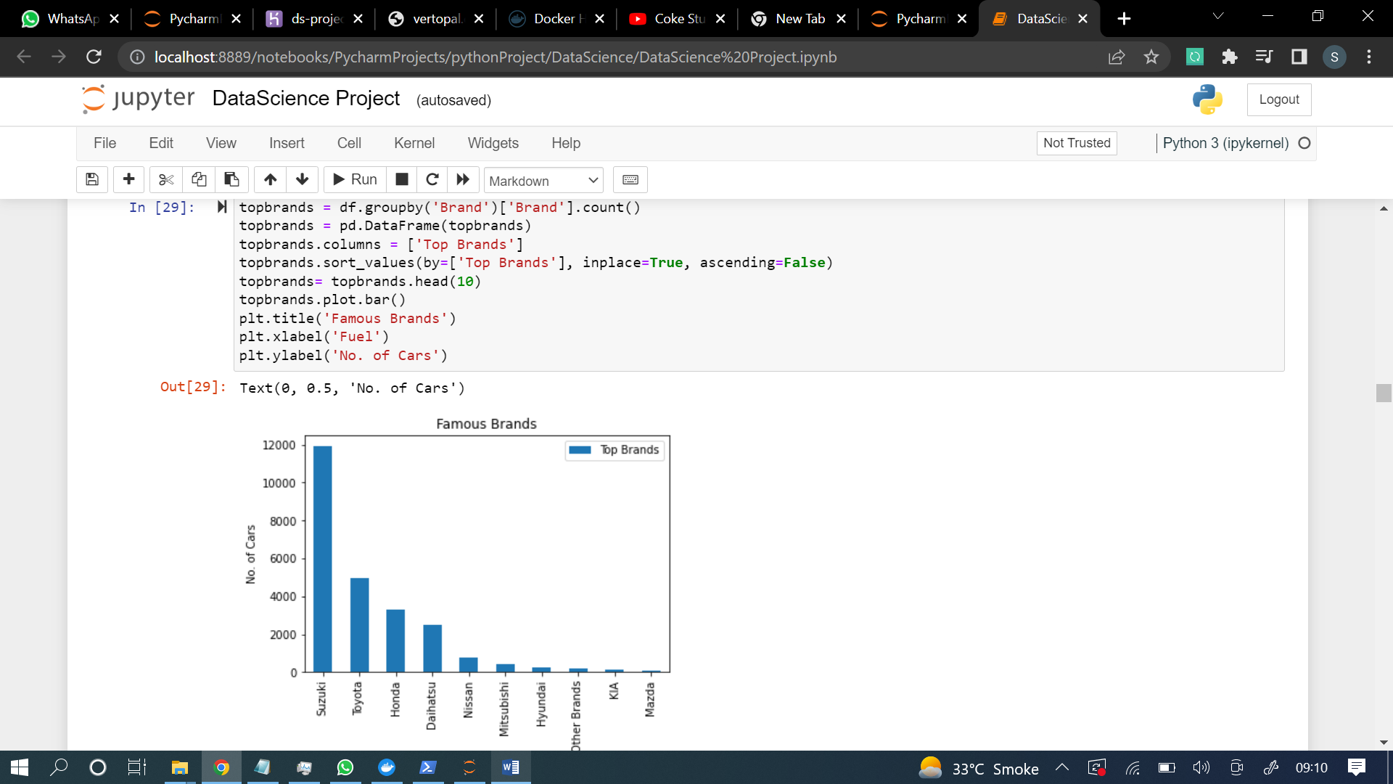

3rd plot(city with highest registration cars)

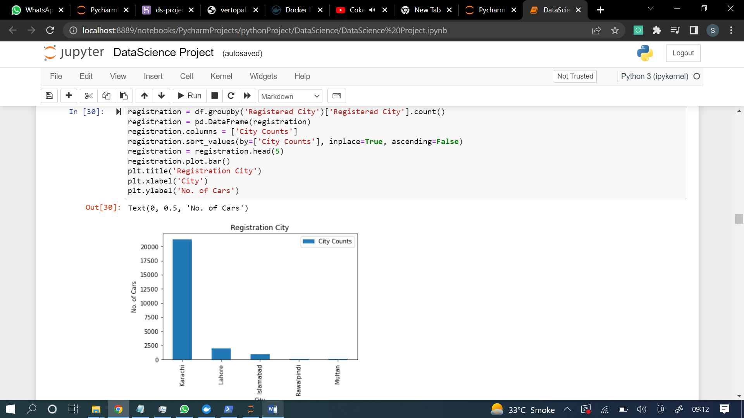

4th plot(most expensive brands in pakistan)

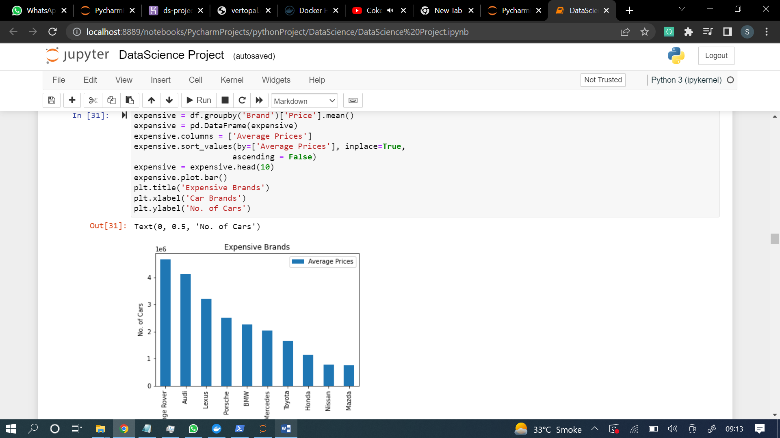

5th plot(xpensive cars)



After visualization I have applied some machine learning models before machine learning model the data was in ordinal or categorical form so used some sklearn libraries and then convert that data into the proper form to get proper results.

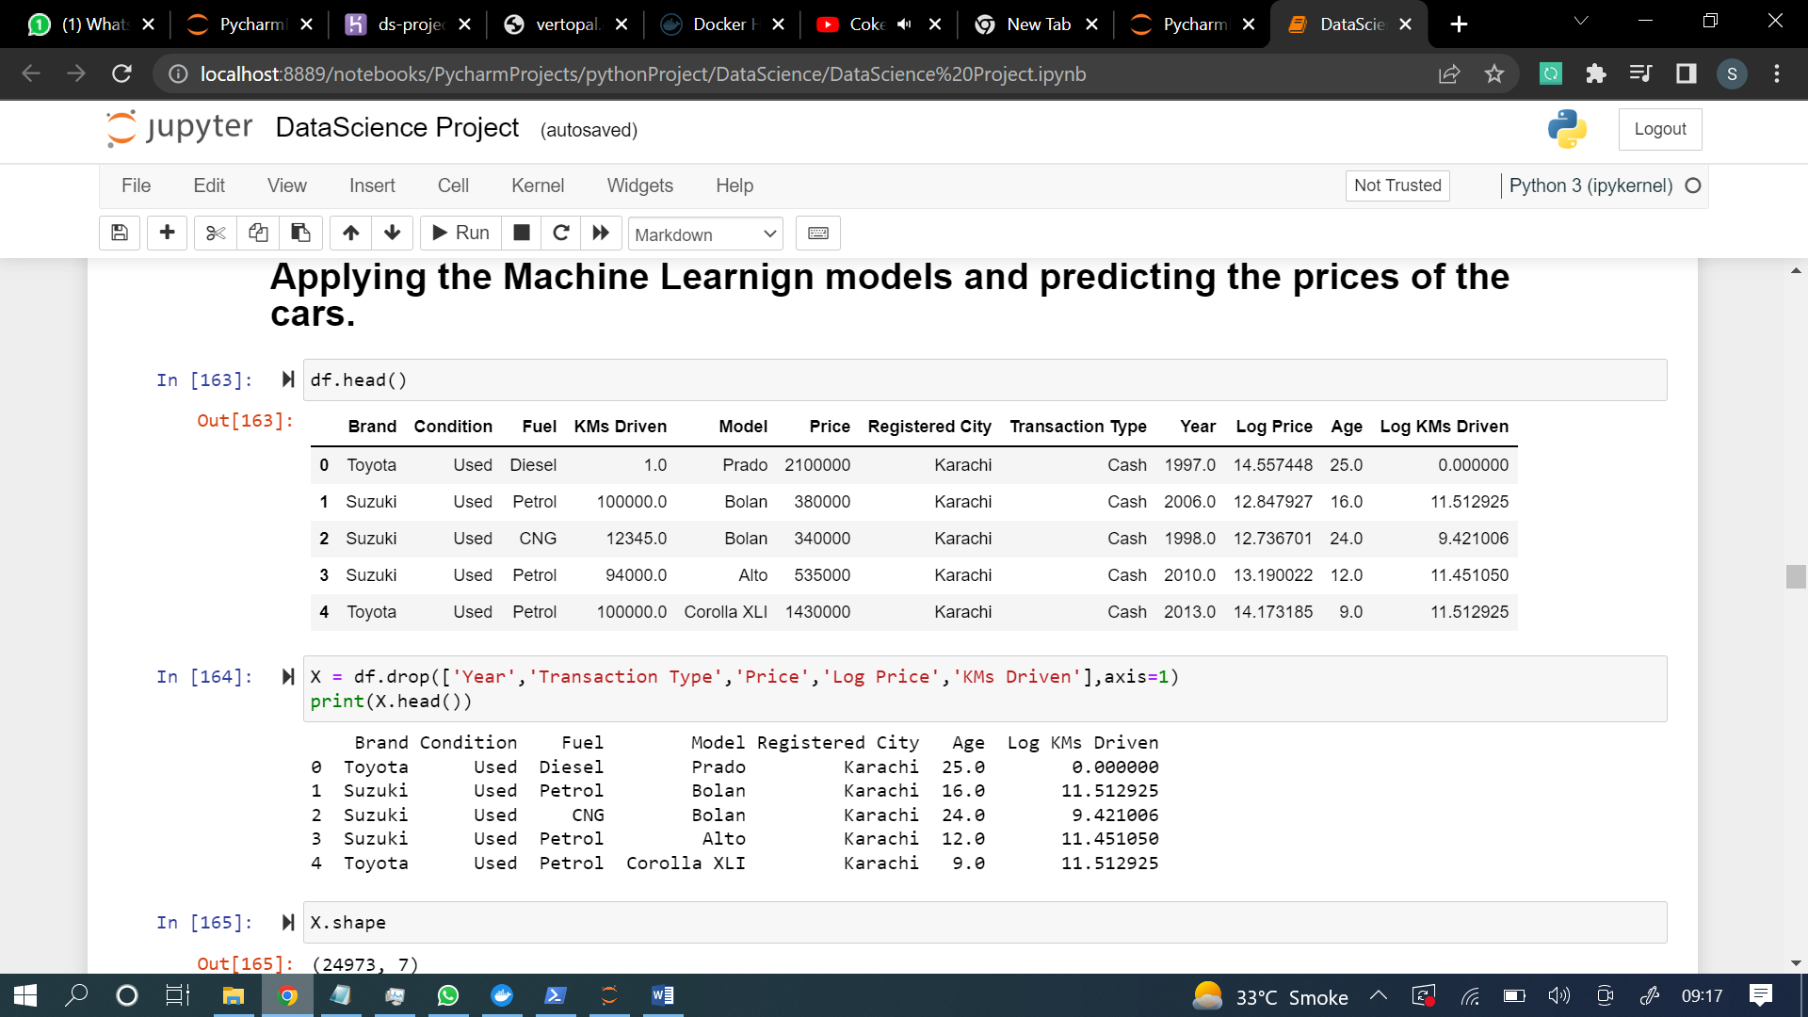

Applied ordinal encoder library to convert the data in ordinal data

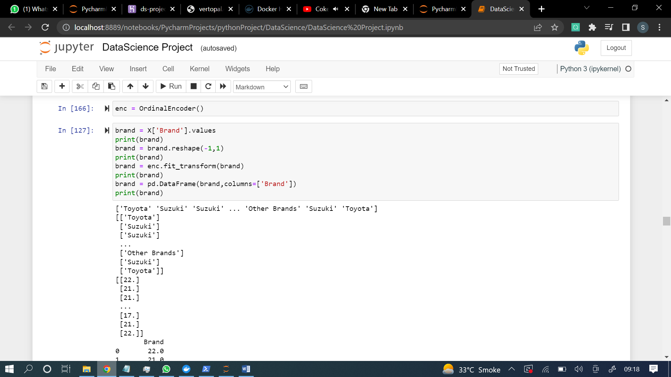

Converting condition feature to ordinal data

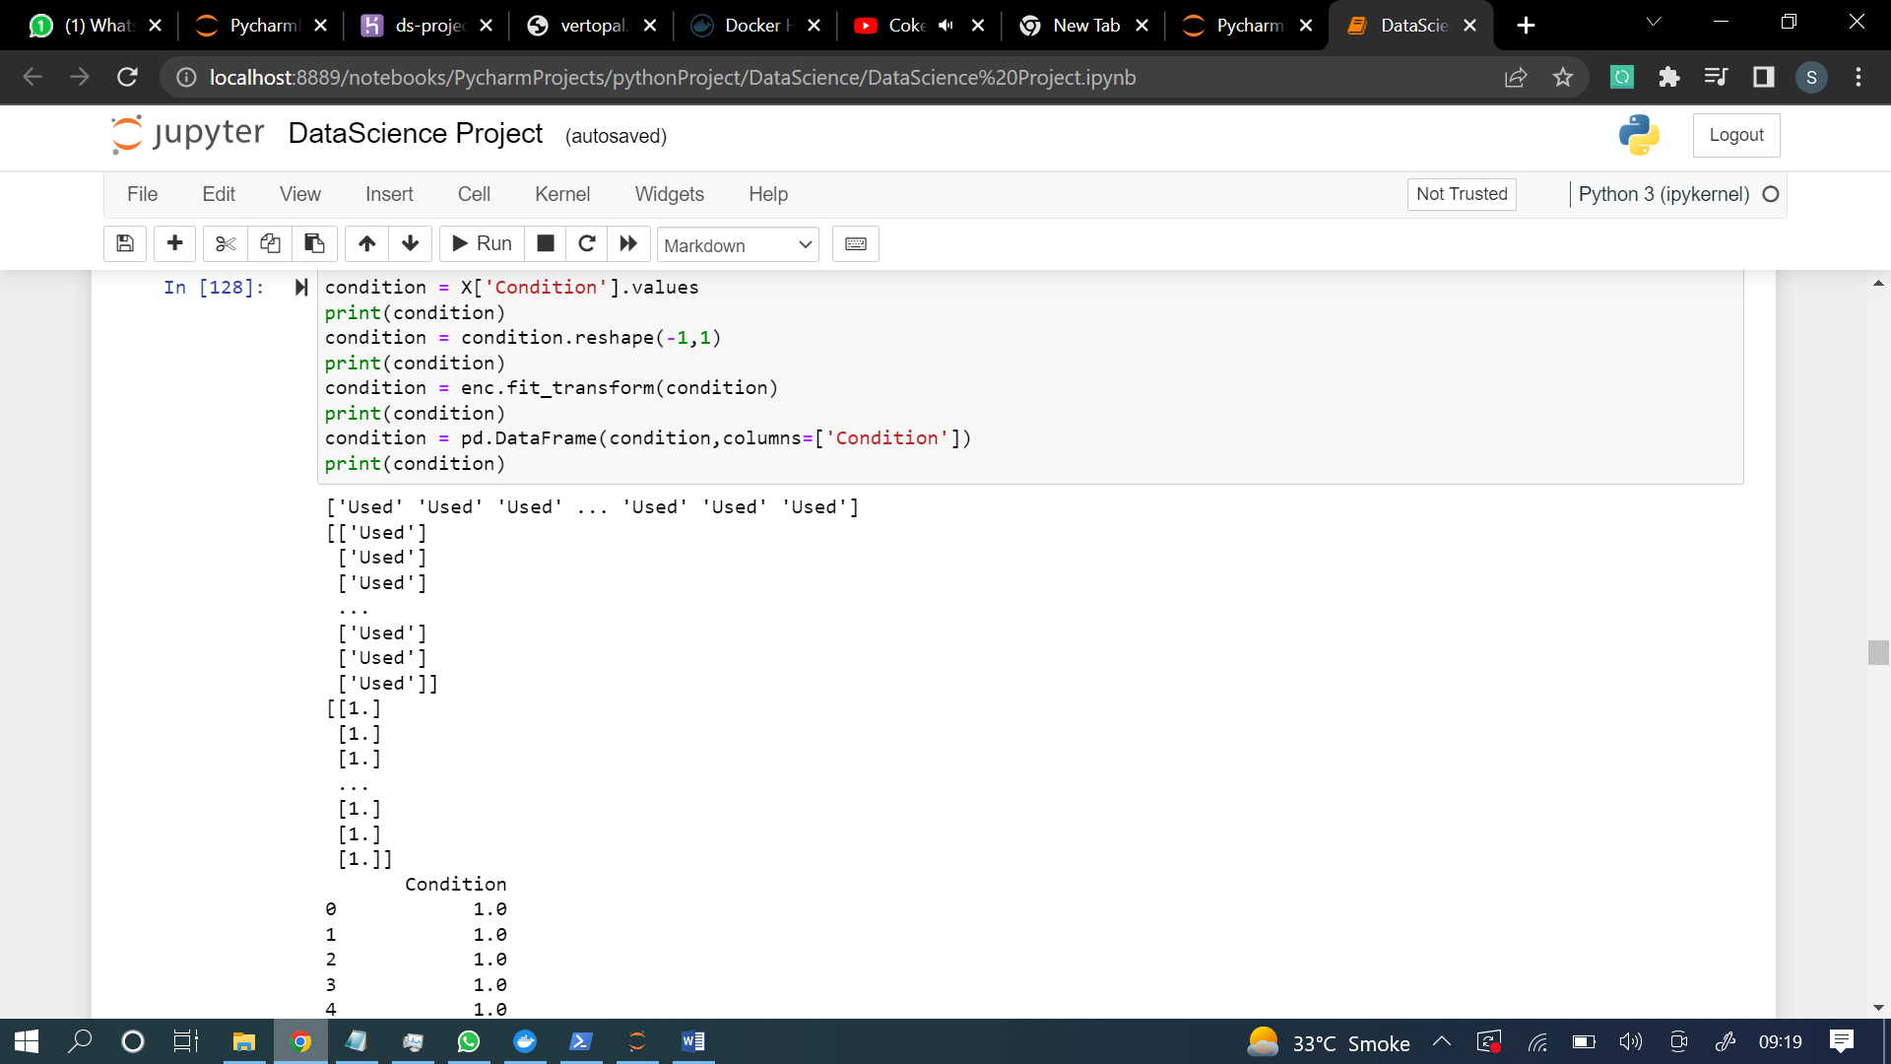

Converting price feature into ordinal feature

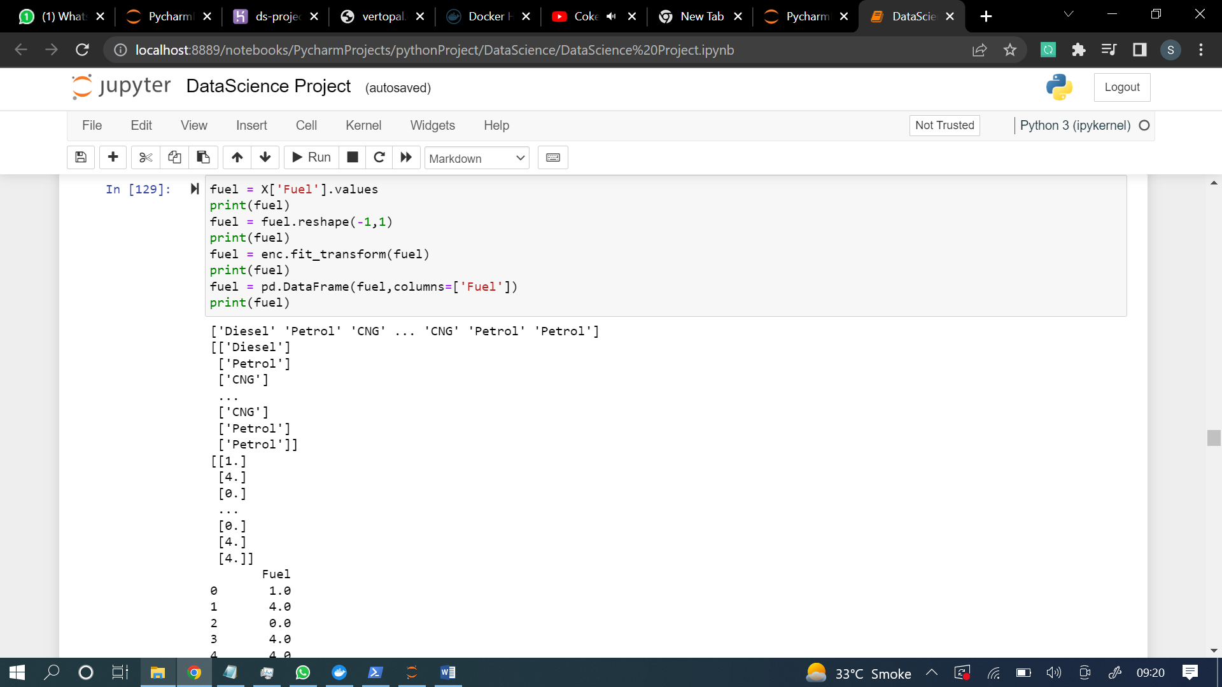

Converting registered city into ordinal feature

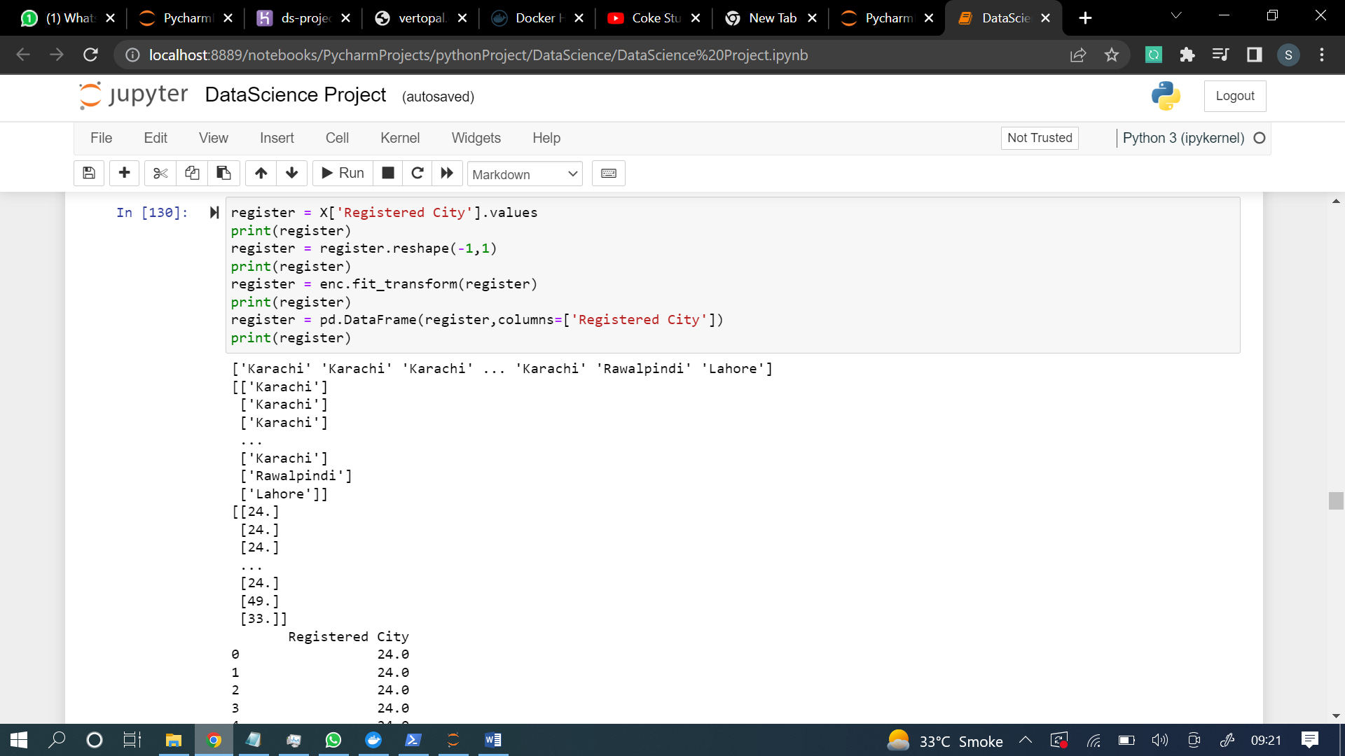

Converting the ordinal data into a table form

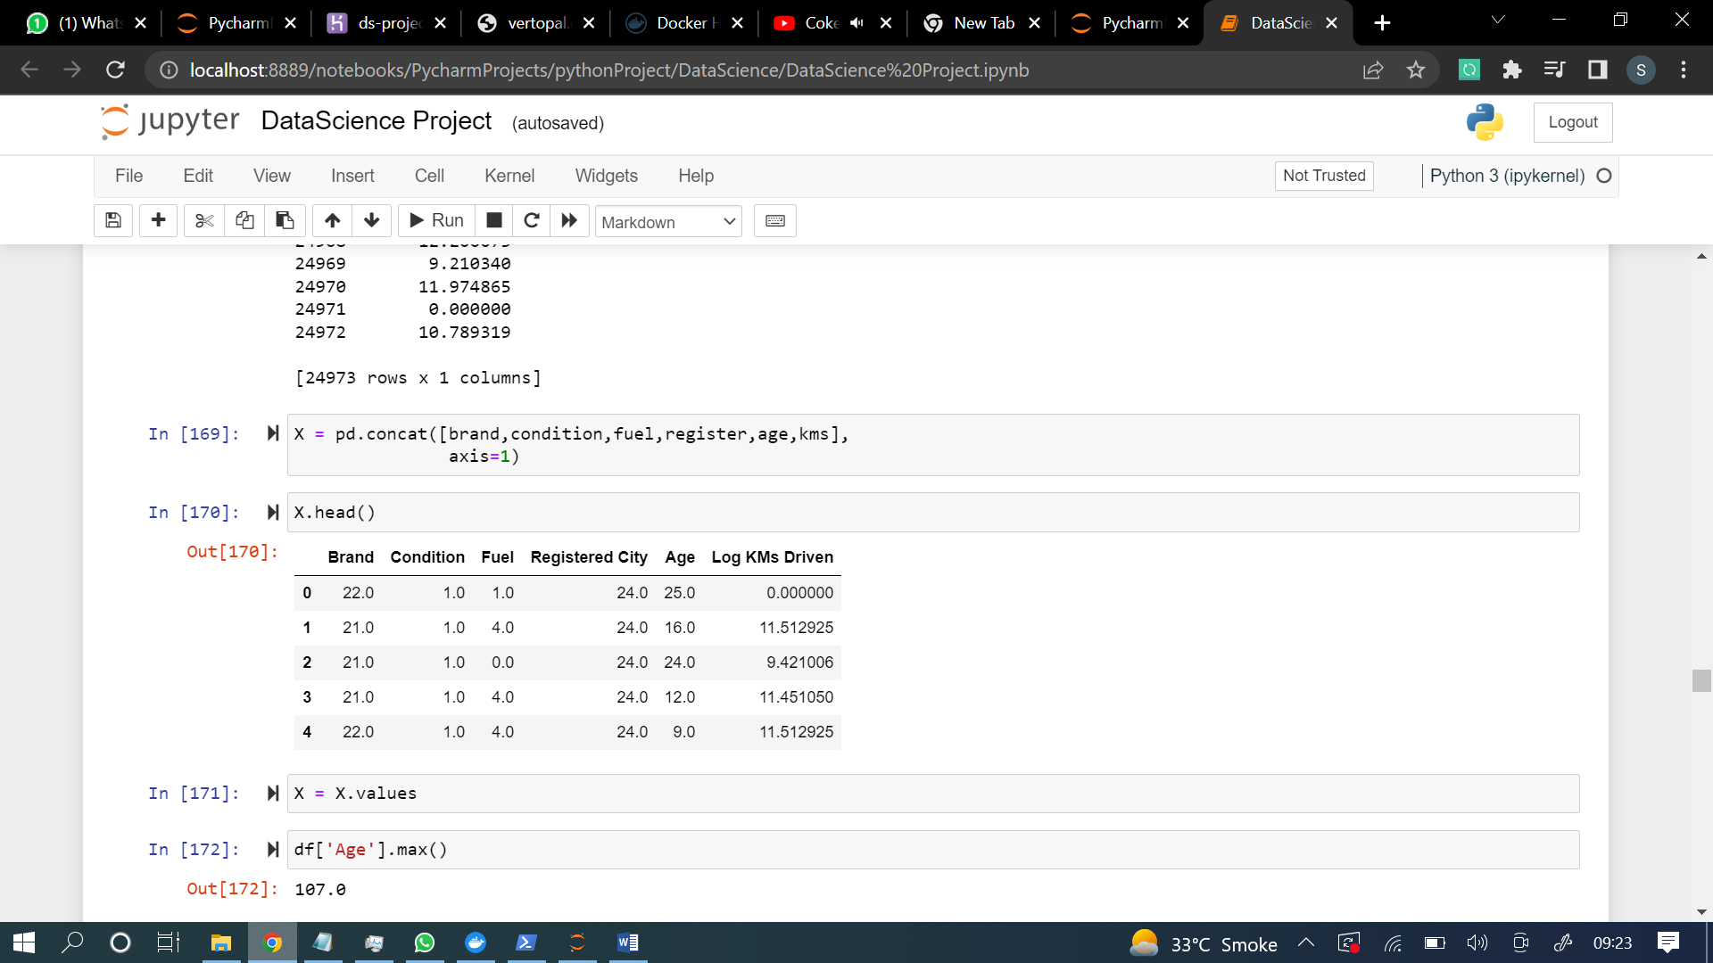

**1st machine learning model**

**Linear Regression**

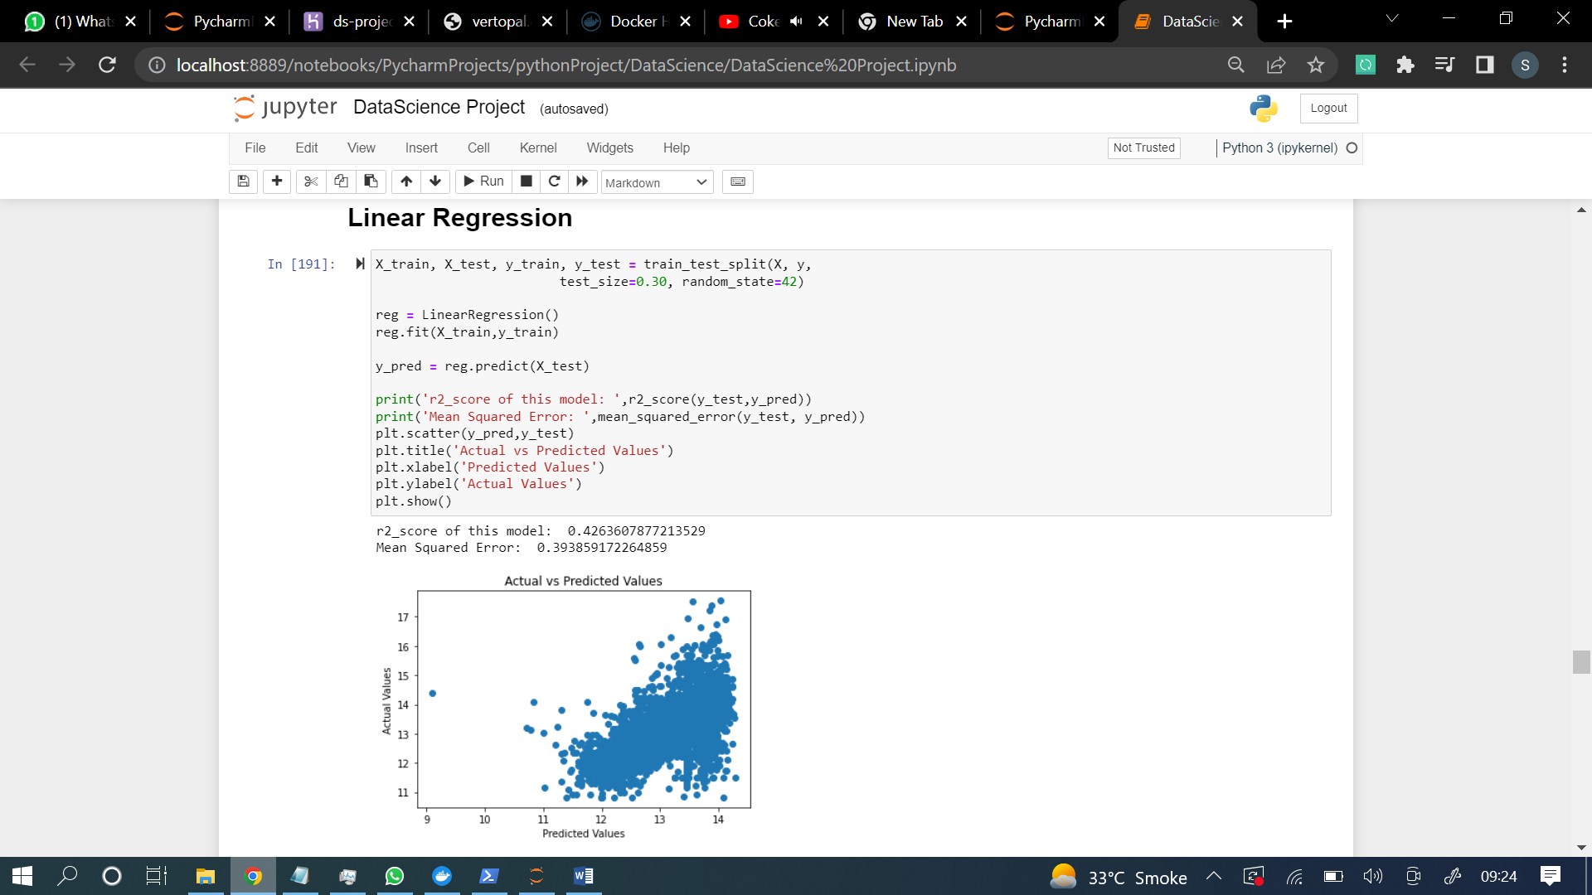

**Gradient Boosting regression**

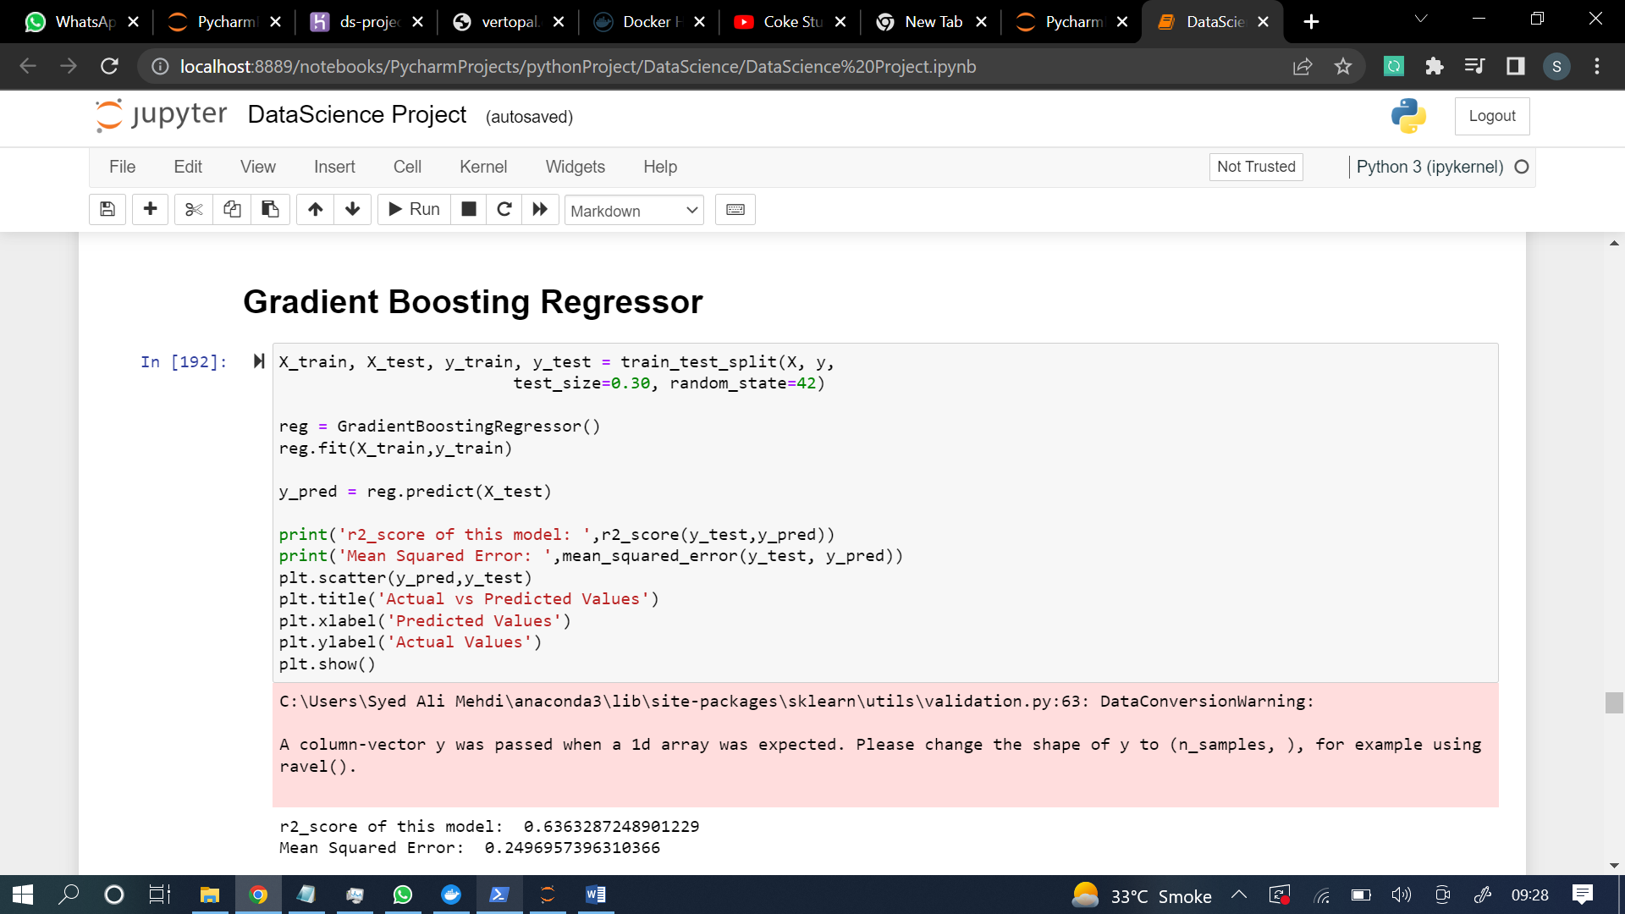

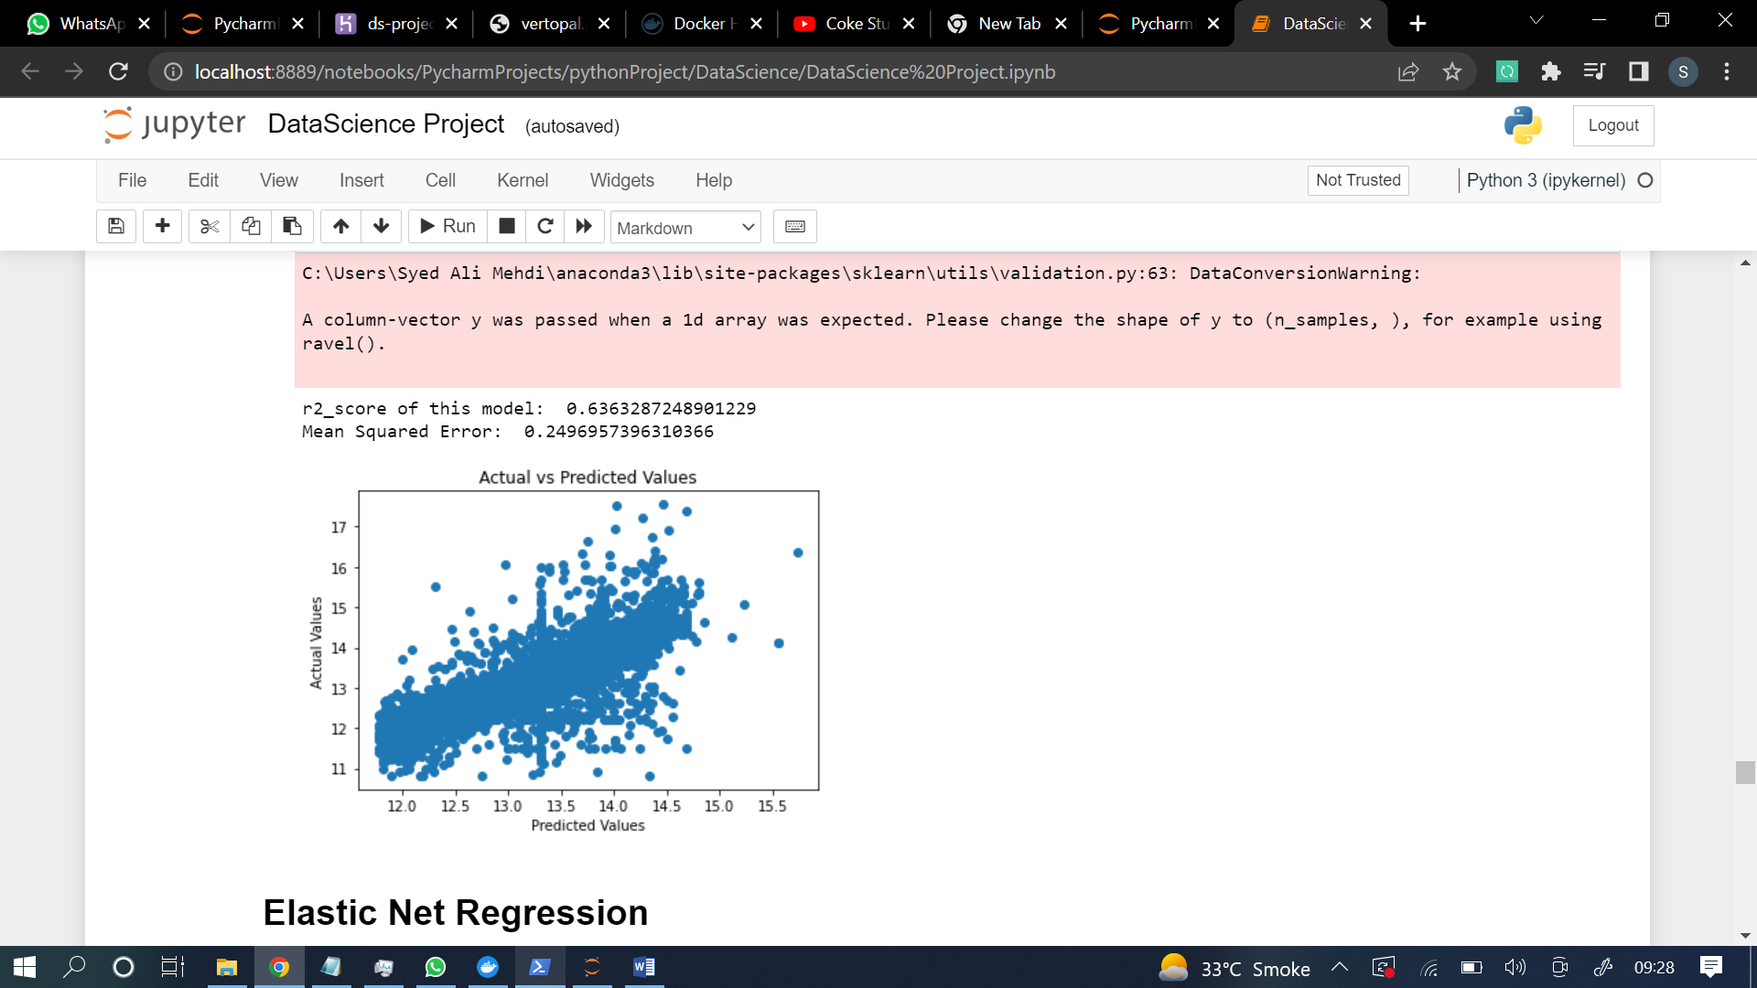

**Elastic net regression**

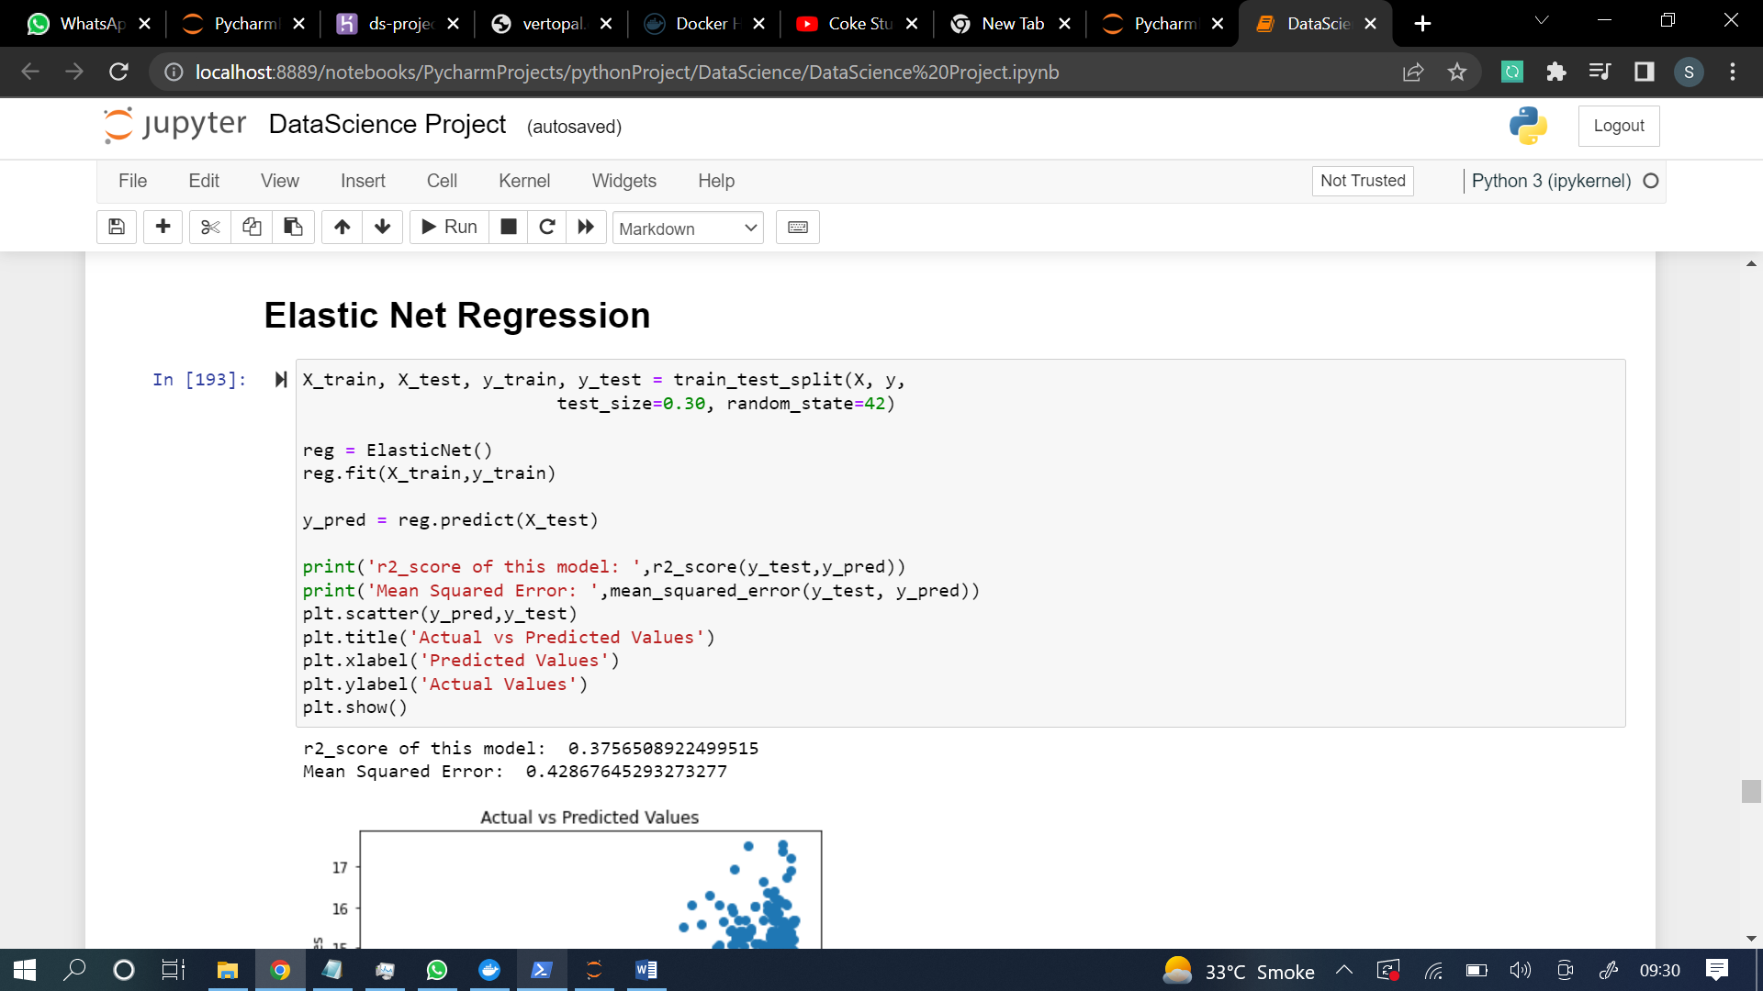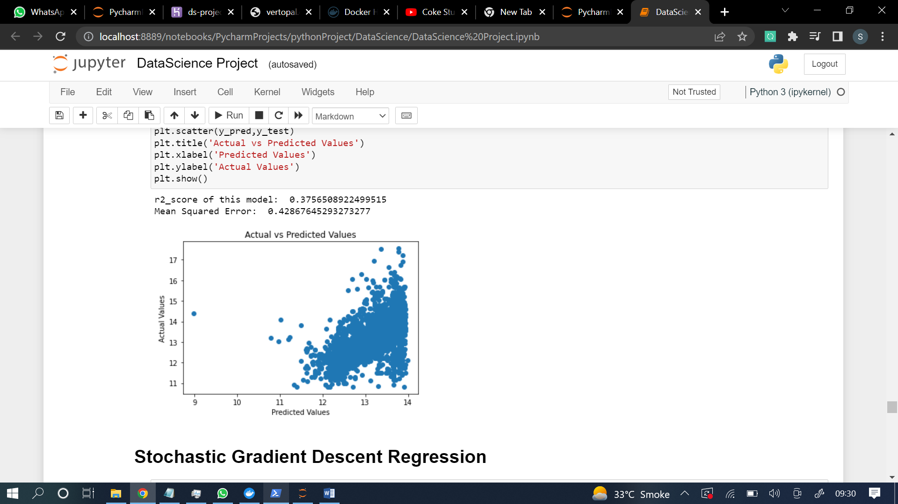

**Stochastic Gradiant Regression**

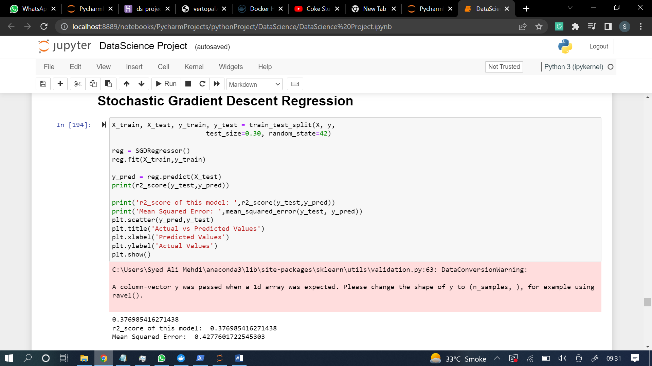

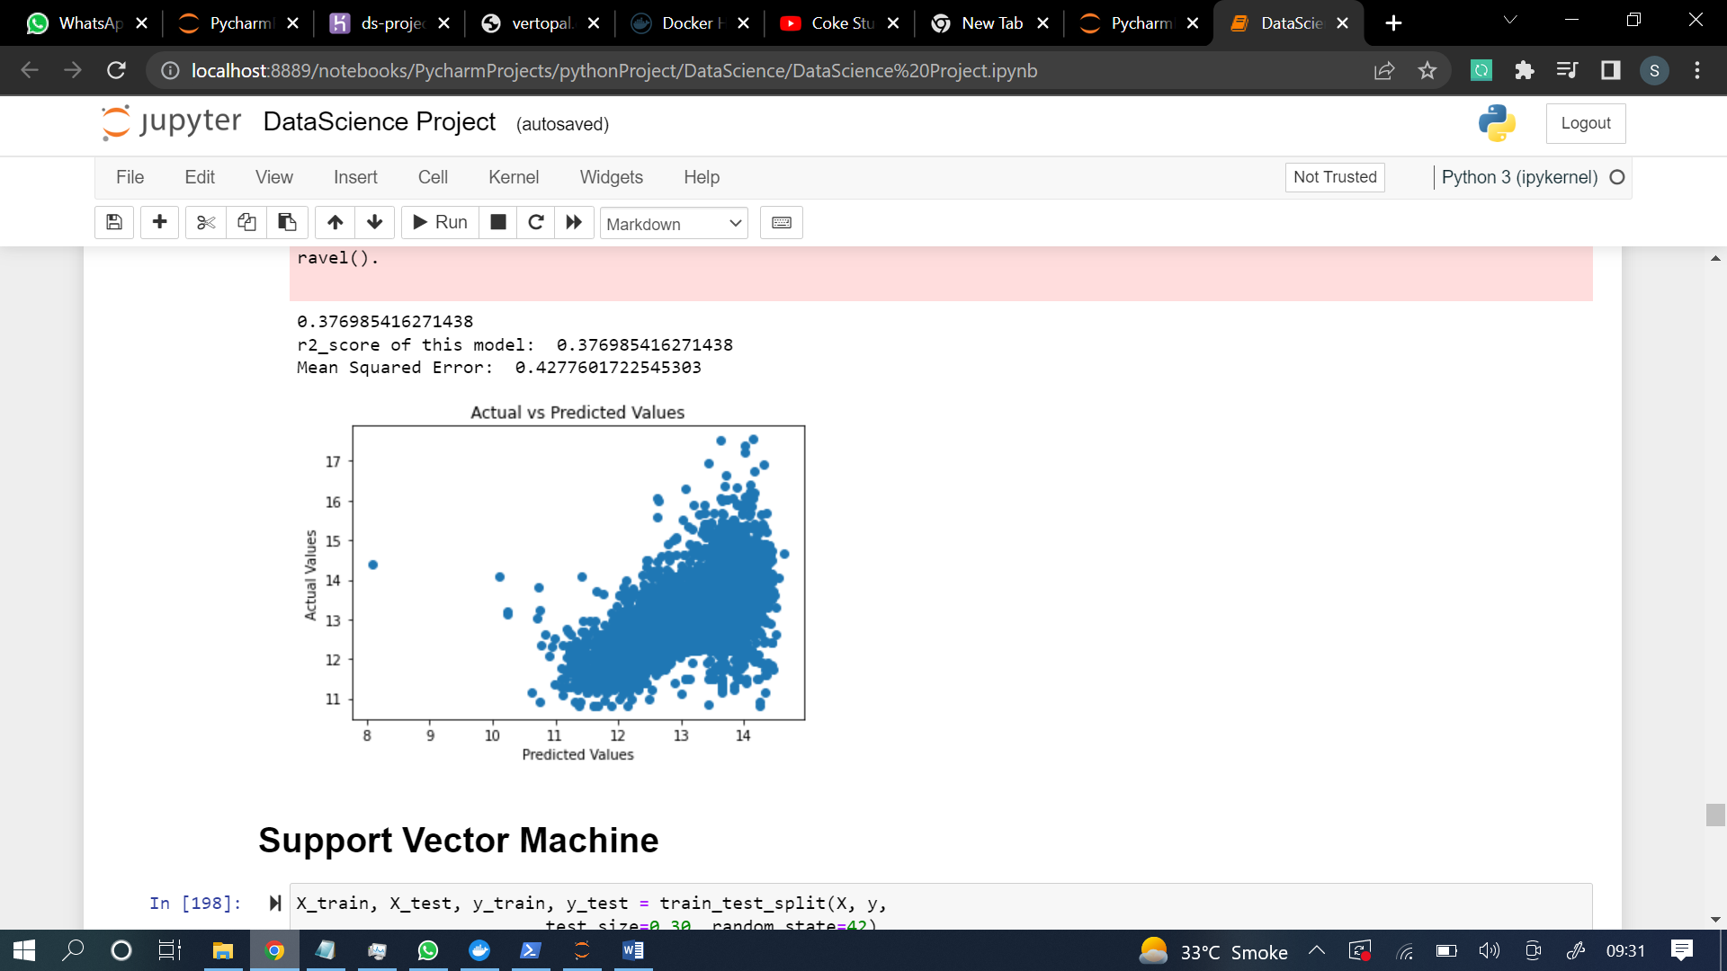

**Support Vector Machine**

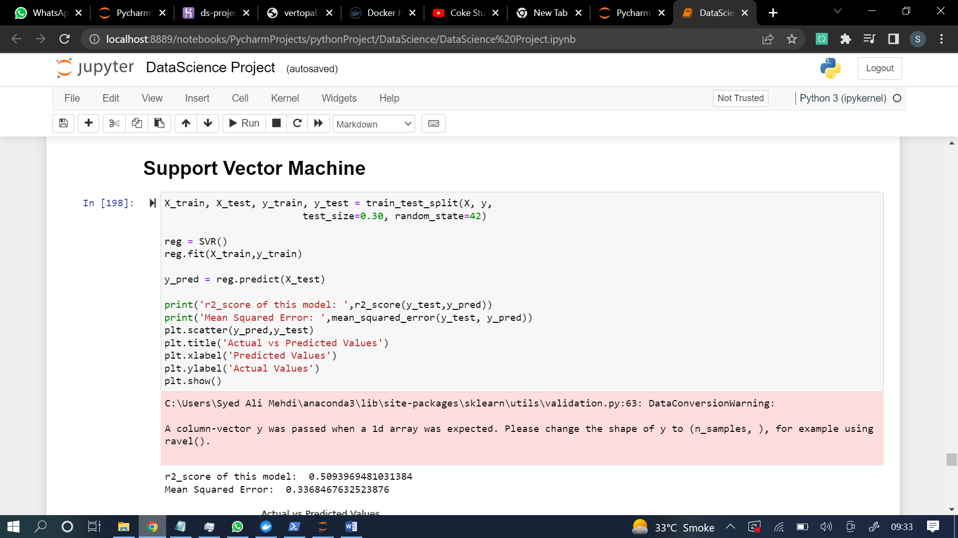

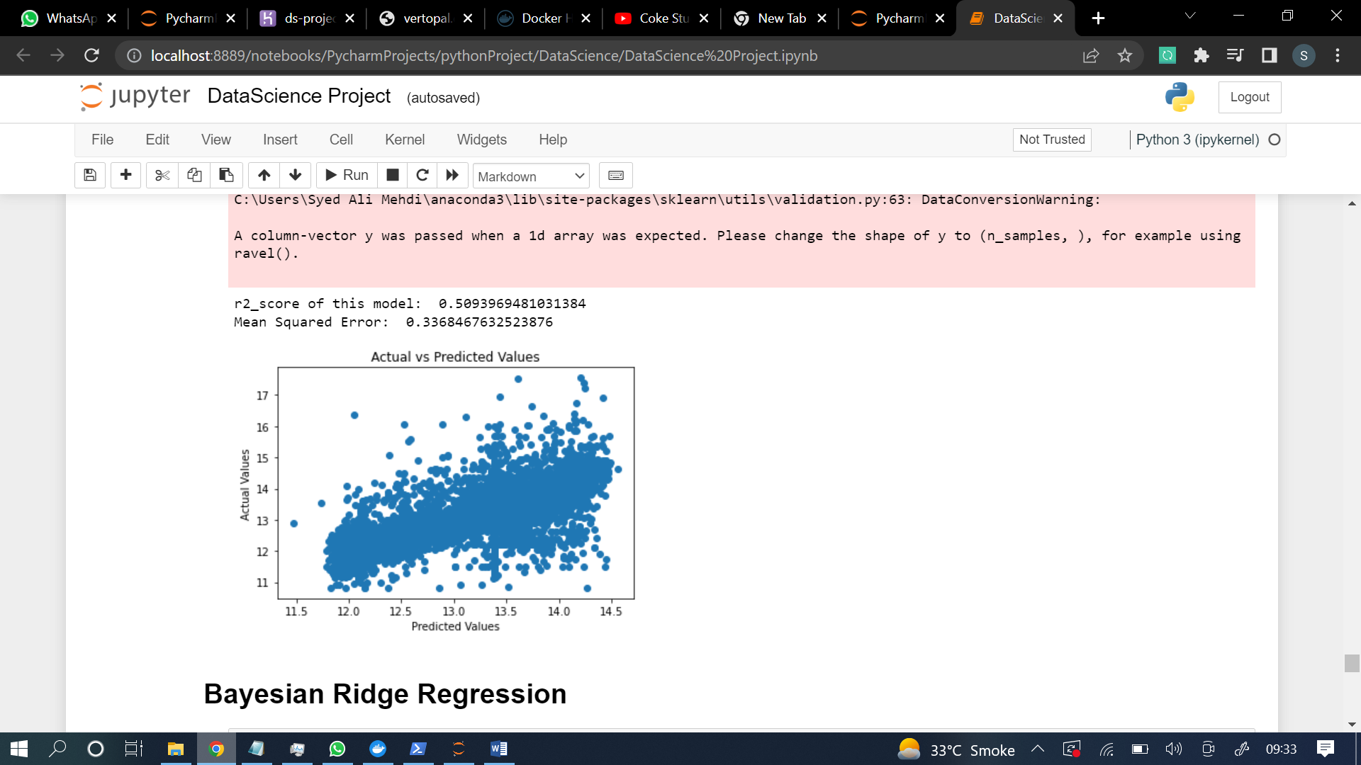

**Bayesian ridge regression**

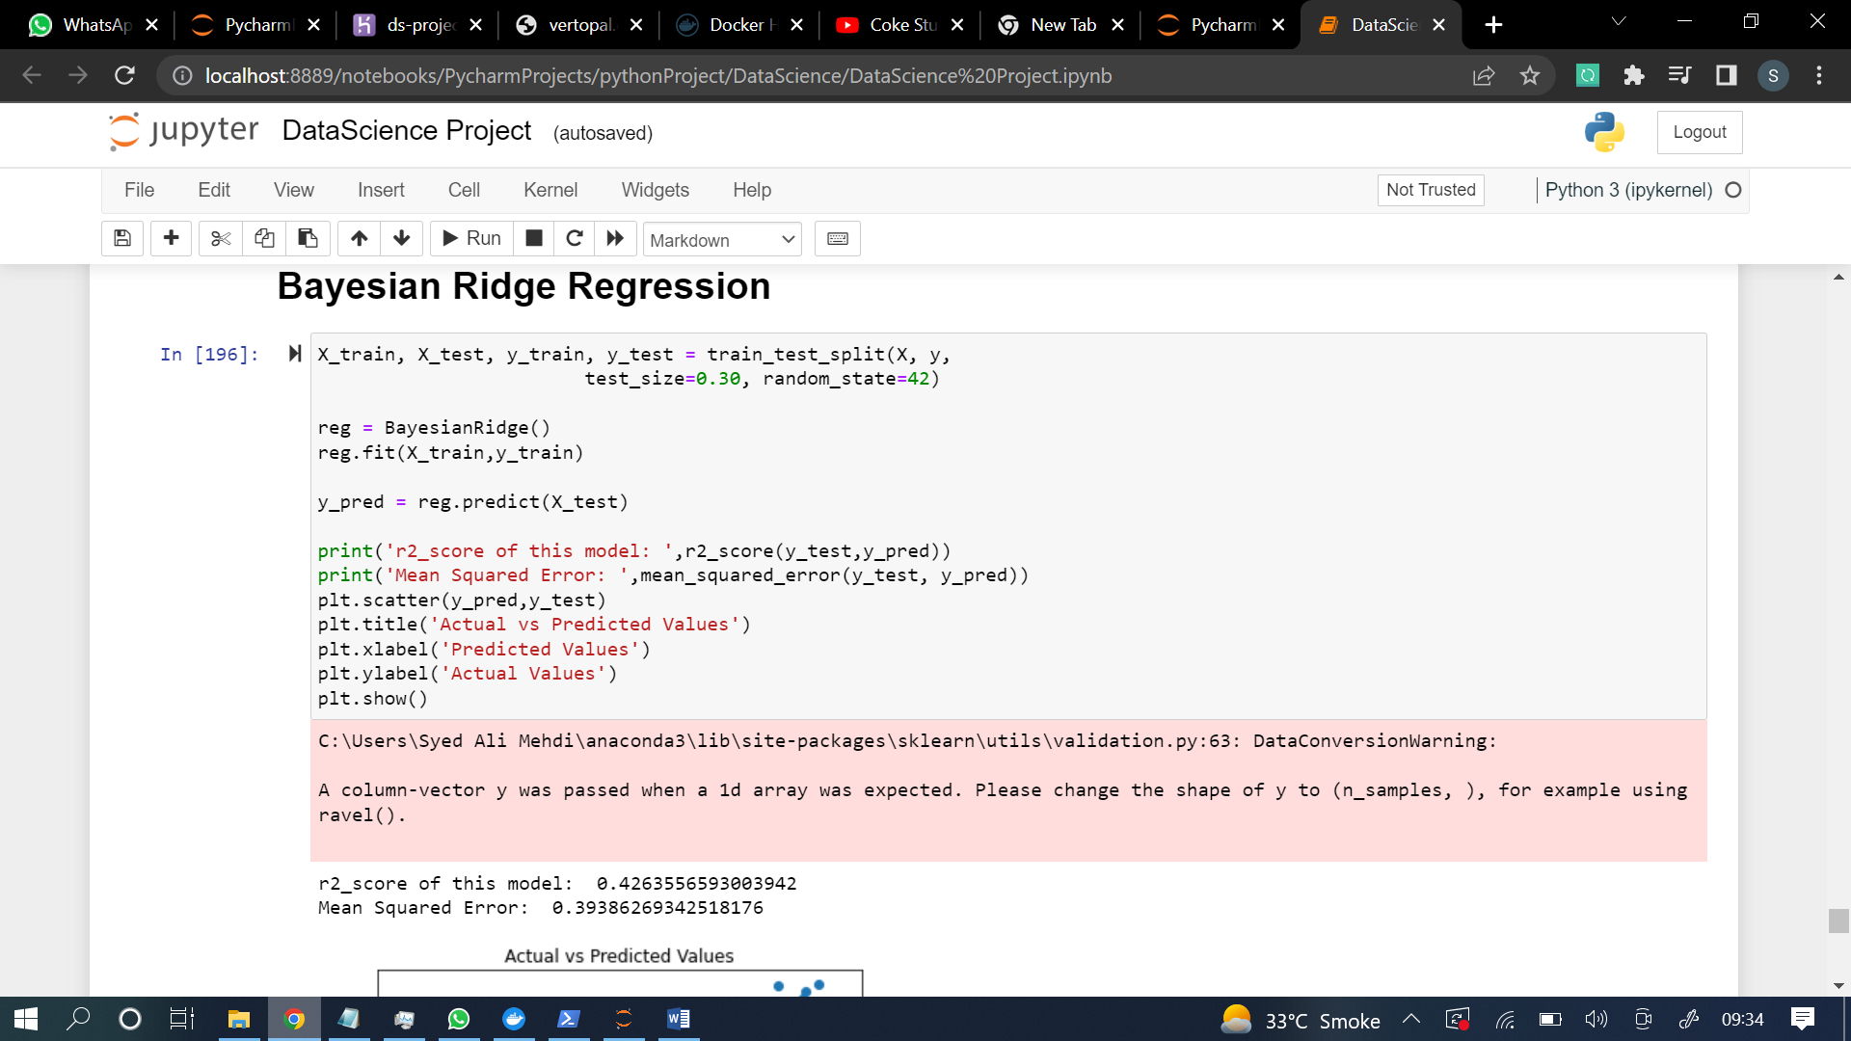

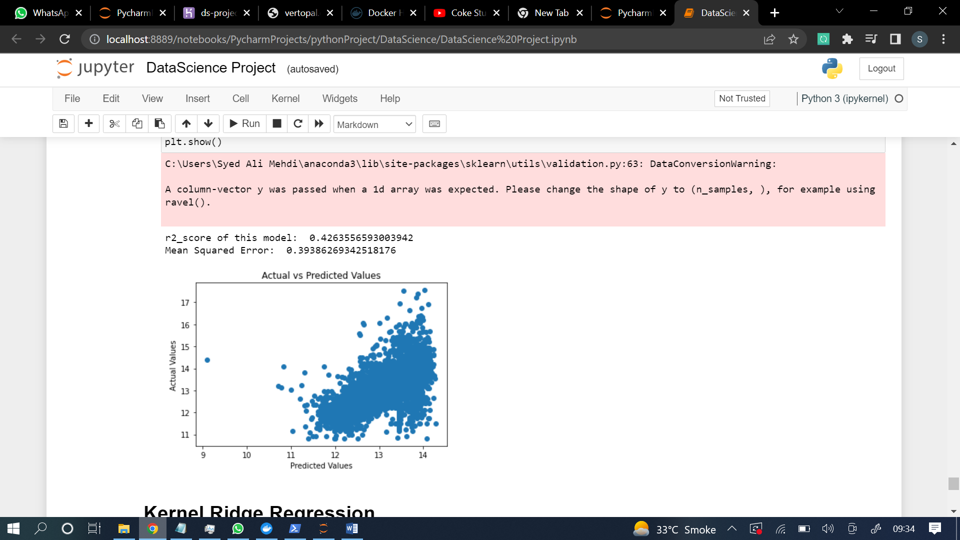

**Kernel Ridge regression**

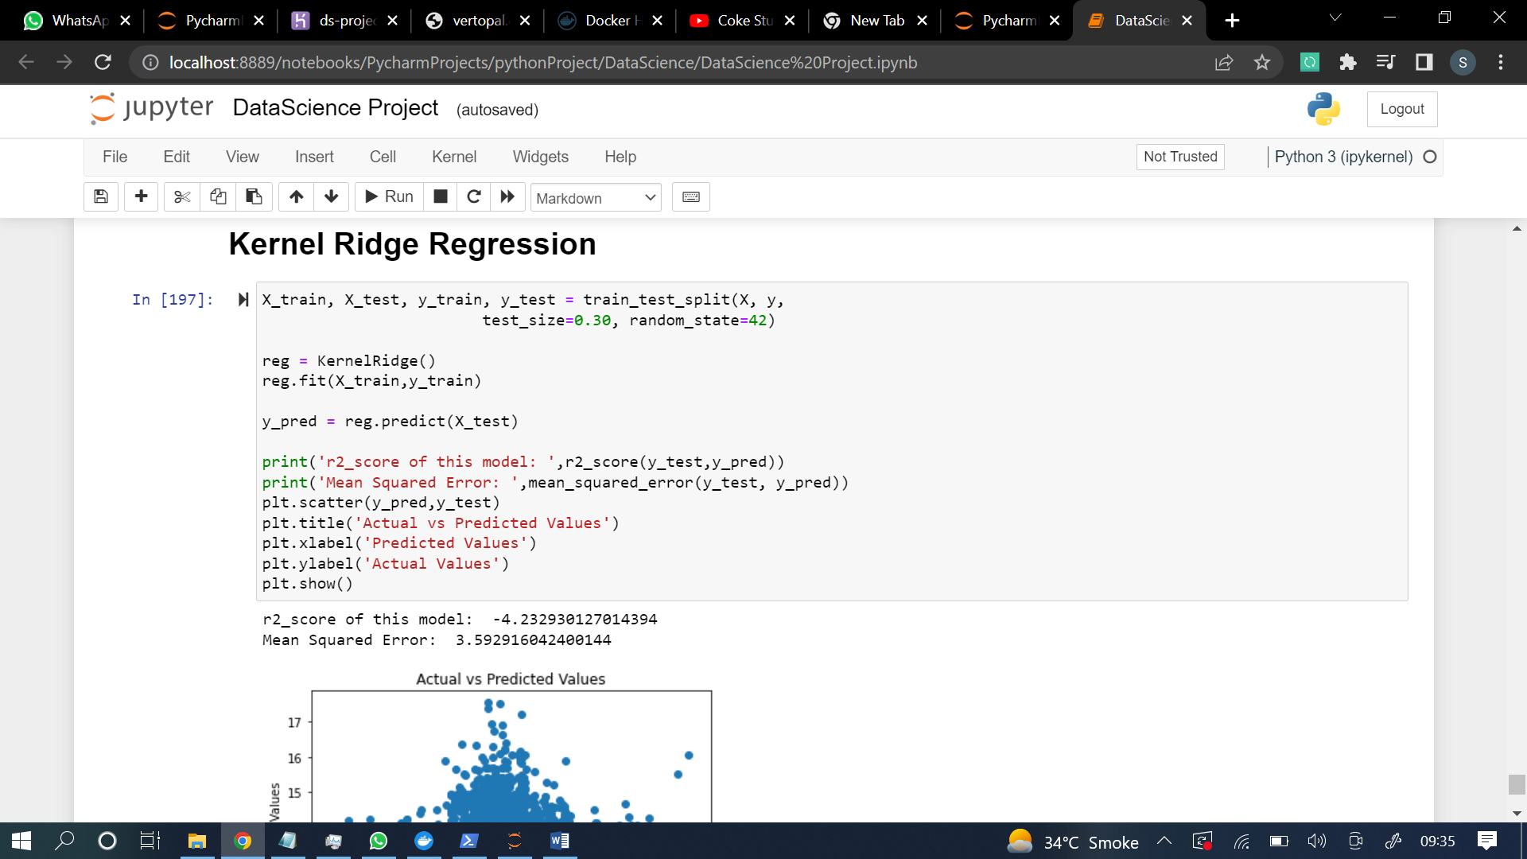

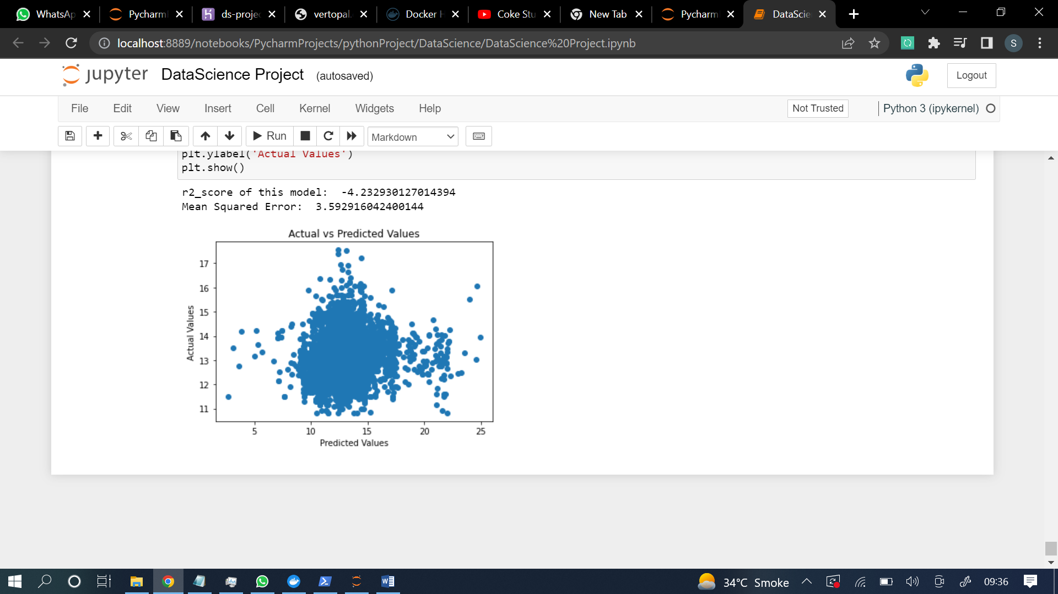

**Deployment of the model:**

**Uploaded on git:**

<https://github.com/sneaky-developer/DSProject>

**Deployed on docker:**

here is the link of the image, u can just run in a container at your machine and specify the port and ip and then that would be executing on your machine browser if u use localhost as ip.